Query the two cities in **STATION** with the shortest and longest *CITY* names, as well as their respective lengths (i.e.: number of characters in the name). If there is more than one smallest or largest city, choose the one that comes first when ordered alphabetically.

**Input Format**

The **STATION** table is described as follows:

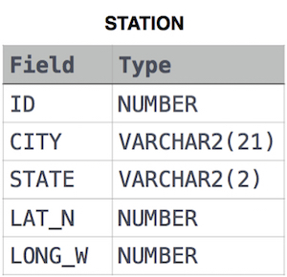

where *LAT_N* is the northern latitude and *LONG_W* is the western longitude.

**Sample Input**

Let's say that *CITY* only has four entries: *DEF*, *ABC*, *PQRS* and *WXY*

**Sample Output**

ABC 3

PQRS 4

**Explanation**

When ordered alphabetically, the *CITY* names are listed as *ABC, DEF, PQRS,* and *WXY*, with the respective lengths and . The longest-named city is obviously *PQRS*, but there are options for shortest-named city; we choose *ABC*, because it comes first alphabetically.

**Note**   
**You can write two separate queries to get the desired output. It need not be a single query.**

Query:-

select min(city), len

from (

select city, length(city) len,

max(length(city)) over() maxlen,

min(length(city)) over() minlen

from station

)

where len in(minlen,maxlen)

group by len;

*-*-*-*-*-*-*-*-*-*-*-*-*-*-*-*-*-*-*-*-*-*-*-*-*-*-*-*-*-*-*-*-*-*-*-*-*-*-*-*-*-*-*-*-*-*-*

Query the list of CITY names starting with vowels (i.e., a, e, i, o, or u) from **STATION**. Your result cannot contain duplicates.

**Input Format**

The **STATION** table is described as follows:



where LAT_N is the northern latitude and LONG_W is the western longitude.

Query:-

select distinct(city) from station where city like 'A%'

or city like 'E%'

or city like 'I%'

or city like 'O%'

or city like 'U%';

*-*-*-*-*-*-*-*-*-*-*-*-*-*-*-*--*--**-**--*-*-*-*-*-*-*-*-*-*-*-*-*-*-*-*-*-*-*-*-*-**-*-*-*

Query the list of CITY names from **STATION** which have vowels (i.e., a, e, i, o, and u) as both their first and last characters. Your result cannot contain duplicates.

**Input Format**

The **STATION** table is described as follows:



where LAT_N is the northern latitude and LONG_W is the western longitude.

Query:-

SELECT DISTINCT CITY FROM STATION WHERE REGEXP_LIKE(LOWER(CITY), '^[aeiou]') and REGEXP_LIKE(LOWER(CITY), '[aeiou]$');